**INSTRUMENTATION DESIGN AND COMPUTER INTERFACING OF PHYSICAL MEASUREMENT SYSTEMS**

A Project Report Submitted

in Partial Fulfillment of the Requirements for the

**Physics Minor Project**

*in*

**School of Physics**

*By*

**Prashant Sharma**

**(Roll No. IMS19175)**



### To

### **SCHOOL OF PHYSICS**

**INDIAN INSTITUTE OF SCIENCE EDUCATION AND RESEARCH THIRUVANANTHAPURAM - 695551, INDIA**

### April 2023

**DECLARATION**

I, **Prashant Sharma** (**Roll No. : IMS19175**), hereby declare that this report entitled “**INSTRUMENTATION DESIGN AND COMPUTER INTERFACING OF PHYSICAL MEASUREMENT SYSTEMS”** submitted to Indian Institute of Science Education and Research Thiruvananthapuram towards the partial requirement of **Physics Minor Project** in **School of Physics** is an original work carried out by me under the supervision of **Dr Vinayak B Kamble** and has not formed the basis for the award of any degree or diploma, in this or any other institution or university. I have sincerely tried to uphold academic ethics and honesty. Whenever an external information or statement or result is used then, that has been duly acknowledged and cited.

Thiruvananthapuram - 695551 **Prashant Sharma**

April 2023

**CERTIFICATE**

This is to certify that the work contained in this project report entitled **“INSTRUMENTATION DESIGN AND COMPUTER INTERFACING OF PHYSICAL MEASUREMENT SYSTEMS”** submitted by **Prashant Sharma** (**Roll No. : IMS19175**) to the Indian Institute of Science Education and Research Thiruvananthapuram towards the partial requirement of the Physics **Minor Project** in **School of Physics** has been carried out by him under my supervision and that it has not been submitted elsewhere for the award of any degree.

Thiruvananthapuram - 695551 (Dr Vinayak B. Kamble)

April 2018 Project Supervisor

**Contents**

| List of Figures   1. Abstract 2. Introduction 3. Lock-In-Amplifier    1. Red Pitaya Board    2. Why do we need Lock-In-Amplifier       1. Working Principle of Lock-In Amplifier    3. Construction       1. Code with Red Pitaya 4. Micro heater    1. Circuit diagram    2. Construction 5. Thermal Expansion using LVDT    1. LVDT    2. Why use LVDT    3. Circuit Diagram for LVDT    4. LVDT With Arduino and calibration       1. Code for Arduino 6. Results    1. Noise reduction and amplification    2. High temperature with the microheater    3. LVDT graph variation 7. Discussion and Conclusion 8. Appendix 9. References | **5**  **6**  **6**  **8**  **9**  **11**  **11**  **14**  **15**  **21**  **21**  **22**  **23**  **23**  **23**  **24**  **25**  **26**  **27**  **28**  **28**  **28**  **29**  **30**  **30** |
| --- | --- |

**List of Figures**

| *Figure 1 Red Pitaya Board (microcontroller with ARM processor)*  *Figure 2 Visuals and RP board Interface*  *Figure 3: use of Lock-in Amplifier*  *Figure 4: Principle Schematic of Lock-in Amplifier*  *Figure 5: Sensor with RP Board*  *Figure 6: GUI of Web Version for Lock-In Amplifier hosted on RP Board*  *Figure 7: Design of micro heater*  *Figure 8: D Flip-Flop and Truth Table*  *Figure 9: Circuit diagram for heater Controller*  *Figure 10: Schematic of Controller Circuit and Heater*  *Figure 11: LVDT Inside View and Position Change View*  *Figure 12: Circuit diagram of LVDT primary winding and Secondary winding*  *Figure 13: Arduino Interface With LVDT*  *Figure 14: Displacement vs Output Voltage*  *Figure 15: Signal noise Detection on Lock-in GUI*  *Figure 16: Signal after Lock-in and eight times Amplification*  *Figure 17: voltage vs time graph for LVDT* | **10**  **11**  **12**  **12**  **14**  **16**  **21**  **21**  **22**  **22**  **23**  **24**  **25**  **26**  **27**  **28**  **29** |
| --- | --- |

**ABSTRACT**

The project comprises designing and constructing three very useful and expensive lab devices in a simplified and cost-effective manner using locally available components: **(i) a Lock-In Amplifier, (ii) Micro Heater Controller Circuit and (iii) Thermal Expansion Measurement Device using Linear Voltage Differential Transducer (LVDT).** (i) Lock-in amplifiers can detect and quantify AC signals as low as a few nanovolts. Therefore, taking precise readings is possible even when the vanishing small signal is overwhelmed by noise a few orders of magnitude greater. This project created a robust mobile Web version of a Lock-in Amplifier capable of measuring extremely weak AC signals, down to a few nanovolts at 50 kHz. (ii) An efficient and evenly heating micro-size heater (operating at a constant low power of about 20 mW) is constructed for use in gas sensor device fabrication. The versatility of the heaters at microscale make them useful for many instrument building involving local heating. (iii) A LVDT based High-temperature Thermal Expansion Measurement system interfacing is undertaken that is controlled by either the Arduino Software Development Environment (IDE) for Windows or any other Python-based IDE.

1. **INTRODUCTION**

The project entails a mobile Web version of a Lock-in Amplifier, a micro-size Thermal Heater, and an LVDT displacement measuring device for Thermal Expansion of Solids.

In the middle of the 20th century, the concept of phase lock-in amplifiers and other electrical devices that could extract signal amplitudes emerged. With a lock-in measurement, signals are only extracted from a small frequency range around the reference frequency, while all other frequencies are effectively filtered out. When measuring a signal in the midst of noise up to a million times bigger than the signal of interest, the most modern instruments on the market today have a dynamic reserve of 120 dB. In physics, engineering, and life science labs, these amplifiers are ubiquitous and used for a wide variety of purposes. Some examples include precision AC voltage and AC phase meters, noise measurement devices, impedance spectroscopy, network analysis, spectral analysis, and phase detectors in phase-locked loops.[1]

In this project, a Mobile Version of Lock-in Amplifier is built and housed on a single ARM-based Microcontroller Red Pitaya Board in order to extract the signal from a very sensitive gas sensor.

In general, sensitive gas sensors need constant high temperatures for experiments. The goal here was to design a little heater that could maintain a steady temperature over the entire sensing area. In order to keep the tungsten micro heater's temperature stable, a circuit was constructed to supply it with a steady current of a few milli-Amp at a high resistance range of 20 Ω- 2 kΩ.

The Thermal Expansion of a given material can be measured using the fact that displacement in one dimension during expansion can be measured with an attached soft iron core to LVDT that generates EMF according to the position of the soft iron core. Here LVDT of a range of half inches was calibrated to measure the displacement of a solid in a closed furnace.

The sections in this report give insights into the working principles of the devices for a thorough understanding and the methods used in this project for their designing in low budget with readily available local components.

**3. LOCK-IN AMPLIFIER**

A Lock-In Amplifier is an amplifier that "locks in" on a signal of a specific frequency and boosts it while canceling out any other frequencies. The lock-in amplifier, also known as demodulation or phase-sensitive detection, works by first mixing the measured signal with a reference frequency and then low-pass filtering the resulting signal. [2]

* Let’s assume that a signal contains two frequencies

* In the lock-in amplifier, the signal is multiplied by a reference function

and the results are filtered using a low-pass filter.

**With simple trigonometric identities one can show that:**

* If the reference frequency ωr is close to ω1, then is a low frequency that will pass through the low-pass filter, while the rest of the terms will be rejected by the filter. In this way, the lock-in can select the frequencies close to the reference frequency. If = ωr and φ = 0, then the lock-in simply measures the amplitude of the signal at .
* If the two frequencies are slightly different, it measures the beats between them.
* One can also determine the phase of the signal relative to the reference. If we multiply the signal by a reference function

then we obtain

* If = ωr, then .

Sometimes it’s also convenient to look at, , which does not depend on the phase of the signal.[3]

The selectivity of an amplifier is set by the frequency at which its low-pass filter cuts off. The lock-in amplifier has a time constant of = , which is more commonly used. Though effective in rejecting noise, a lengthy time constant (low cut-off frequency) reduces the lock-in's responsiveness to variations in the signal. Faster response times are achieved at the expense of increased signal noise when using a small time constant (high cut-off frequency).

A very weak signal can be detected using this method in conjunction with modulation techniques. The concept is to turn on and off a tiny signal at a specified frequency and then to detect the response using a lock-in referenced to the same frequency. [3]

**3.1 Red Pitaya Board**

Definition 3.1.1: **ADC**

An ADC is a device used to convert analogue signals, as those generated by gas sensors, into digital signals. An analog-to-digital converter (ADC) is any electronic device that accepts a voltage or current as input and produces a digital number representing the input's value. Typically, the digital output is a binary number with a value greater than or equal to the input.

Definition 3.1.2: **DAC**

DAC is a Device which converts a set of digital signals into analog signals.

Definition 3.1.3: **ARM Processor**

CPUs from the ARM family use a RISC architecture, which stands for reduced instruction set computer. The Advanced RISC Machine (ARM) processors are superior to the x86 Architecture in server applications.

Definition 3.1.4: **FPGA**

The core of a field programmable gate array (FPGA) is a matrix of configurable logic blocks (CLBs) linked together by programmable interconnects. After production, FPGAs can be reprogrammed to meet the specific needs of a given application or set of functions.[4]

The same as Arduino, the Private company "Red Pitaya" develops instruments for use in research and development, quality assurance, and quality control in the engineering and laboratory sectors. The product is the STEMlab-board, which is also the company's original name. This embedded device combines a computer with an ARM processor, an FPGA, and an electrical board with analog-to-digital converters and digital-to-analog converters. As the software is deployed on the board's server, it can be used in place of an oscilloscope or a Keithley multimeter and controlled remotely. With an FPGA, we can programme any pin to perform an action, whether it be an ADC or DAC. Two of the Analogue I/O ports are inputs, and the other two are outputs, making for a total of four highly sensitive Analogue I/O. It can serve as a replacement for multiple different kinds of test equipment thanks to its wide range of capabilities.

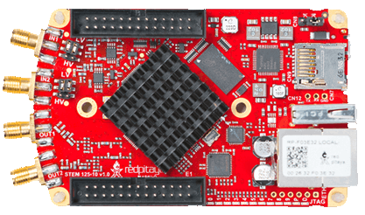

Figure 1 Red Pitaya Board (microcontroller with ARM processor)

It can measure analogue signals up to 50MHz and can be used for signal analysis and measurements. The application is hosted on the board itself, so there is no need to install any other software for analysis. Anyone can access them in a Web Browser using any Operating system. [*5*]

Figure 2 visuals and RP board Interface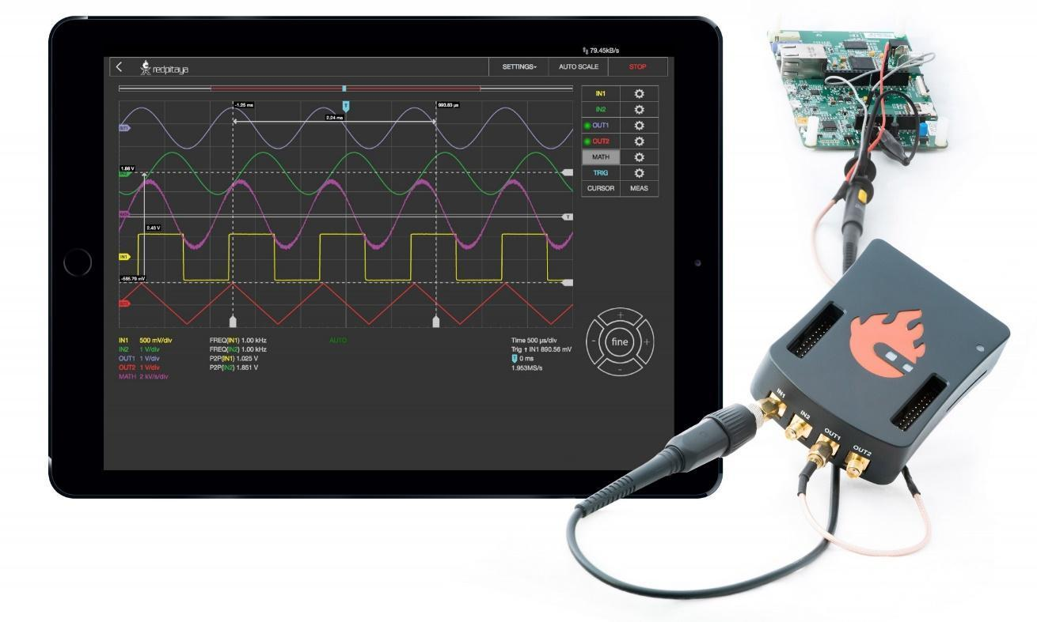

**3.2 Why do we need Lock-In-Amplifier**

Even a small shift in gas concentration can be picked up by a gas sensor because of the sensor's high sensitivity. This sensor generates a voltage change. Some of them can be picked up, but the noise makes it difficult to do so for the vast majority. A radio telescope, for example, picks up far more background noise than valuable signals.

The ratio of noise to signal becomes quite high under these conditions. The genuine signal hidden within the noise will be lost if we attempt to enhance both the signal and the noise. The employment of a lock-in amplifier is one solution to these issues.

**3.2.1 Working Principle of Lock-In-Amplifier**

The input signal is "down-mixed" (multiplied) with a reference signal in a lock-in amplifier, and the resulting signal is filtered with an adjustable low-pass filter. This technique, known as demodulation or phase-sensitive detection, filters out all except the signal at the desired frequency. The reference signal might be produced by the lock-in amplifier or supplied by an external source.

A sine wave is a common shape for the reference signal, but other waveforms are possible. Selective measurement at the fundamental frequency or any of its harmonics is made possible via demodulation with a pure sine wave.[6]

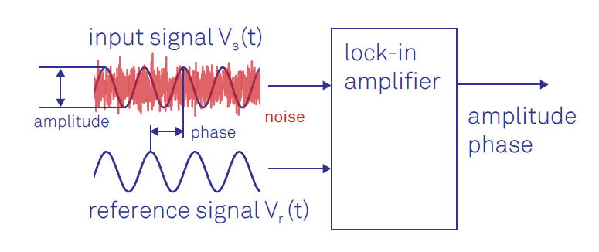

Figure 3: use of Lock-in Amplifier 

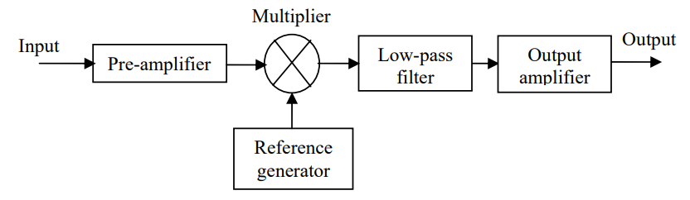

Figure 4: Principle Schematic of Lock-in Amplifier.

1. **Multiplier**

The lock-in relies on multiplying the input signal by the reference signal. Analogue multipliers accurately construct the transfer function Vout = V1 V2 by utilizing the non-linear characteristics of transistors and a large amount of supplementary circuitry. The AD635 is representative of this type of chip.

1. **Reference generator**

We require a sine-wave capable oscillator to generate a sine reference wave. Any amplifier capable of producing positive feedback (like high-pitched audio feedback is capable of producing this. However, a high-quality sine wave free of distortion requires careful regulation of the oscillator's strength. The Wien-bridge oscillator and TLE4121 operational amplifier from Analog's AN-580 application note are two such examples.

It is sufficient to construct a square-wave oscillator by using a switch to multiply a signal by a square wave. The LM555 timer chip is commonly used for this purpose. The reference frequency is sometimes decided by something other than personal preference. Since the purpose of the device is to track and maintain the selected frequency, regardless of whether or not the frequency is stable, the word "lock-in" may be the aptest here. To do this, a "Phase-Locked-Loop" (PLL) is typically used, which is an oscillator whose frequency is locked to an external reference. In practice, the LM565 Phase-Locked Loop (PLL) chip can be used. Think about the phase of your signal in relation to the reference. If they are out of phase by more than 90 degrees, there will be no output. Therefore, it is beneficial to allow for the signal and reference to have a variable phase difference. An RC delay circuit is one such solution.[3]

1. **Pre-Amplifier**

The pre-amplifier is designed to boost the volume of a weak signal. Different pre-amplifiers are used for various inputs. To avoid noise on the ground lines when doing differential measurements, an instrumentation amplifier is commonly used. To convert a current input (from a photo-diode, for instance) into a voltage output, an operational amplifier is typically utilized. The AD622 instrumentation amplifier or the op-amp TLE2141 could be utilized.

1. **Low-pass filter**

The lock-in's output bandwidth is set by the low-pass filter, which also eliminates the first and second harmonics of the reference signal multiplied out. The filter's cut-off frequency needs to be well below the lock-in operating frequency. Passive components, such as an RC filter, or R and C components in conjunction with an operational amplifier, can be used to create a low-pass filter. The filtering process is repeated to achieve a more precise frequency cut-off.

1. **Output amplifier**

The residual voltage is proportional to the signal we are seeking to measure and, as a result, will be negligible after the filter removes signals at the reference frequency and above. This allows the signal to be amplified without the need for a huge reference signal, which could cause the amplifier to fail. The situation calls for a high-gain amplifier, which can be realized with only one or two stages of operational amplifiers (op-amps).[3]

**3.3 Construction**

1. The Red Pitaya Signal Source was connected to one of the Red Pitaya's input channels.
2. The input channel was configured to provide a synchronized, high-resolution analog-to-digital conversion of the input signal.
3. Red Pitaya's digital processing capabilities were used to demodulate the input signal, extract the amplitude and phase of the desired component, and filter out any unwanted noise or interference.
4. use Red Pitaya's digital-to-analog conversion, to output the demodulated signal.
5. The frequency and phase of the demodulation using the Red Pitaya's digital inputs and outputs.

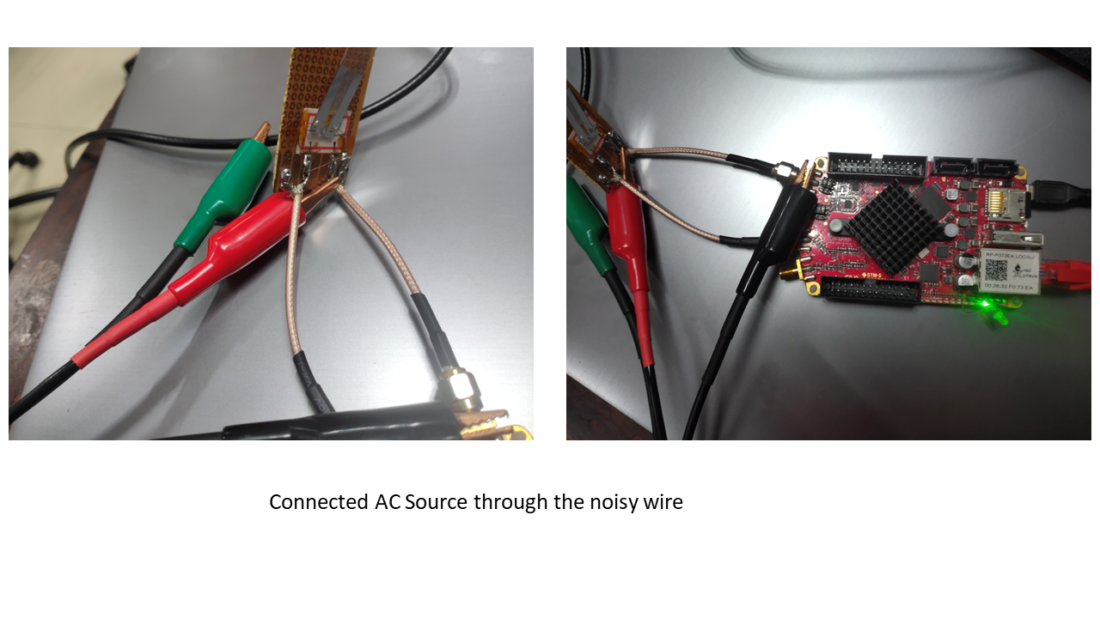

Figure 5: Sensor with RP Board

**3.3.1 Code with Red Pitaya**

* The physical variables that we want to stabilize against environmental changes can be measured and converted into an electrical signal.
* Input1 is taken from Red Pitaya.
* With Lock-in+PID, one can stabilize it to a desired offset voltage value using an *error* signal (*error = Input1 - Offset*) that feeds a PID filter.
* The PID output is a correction signal that can be added to the *control* signal that actually controls the physical system. This is called a closed-loop scheme.[7]

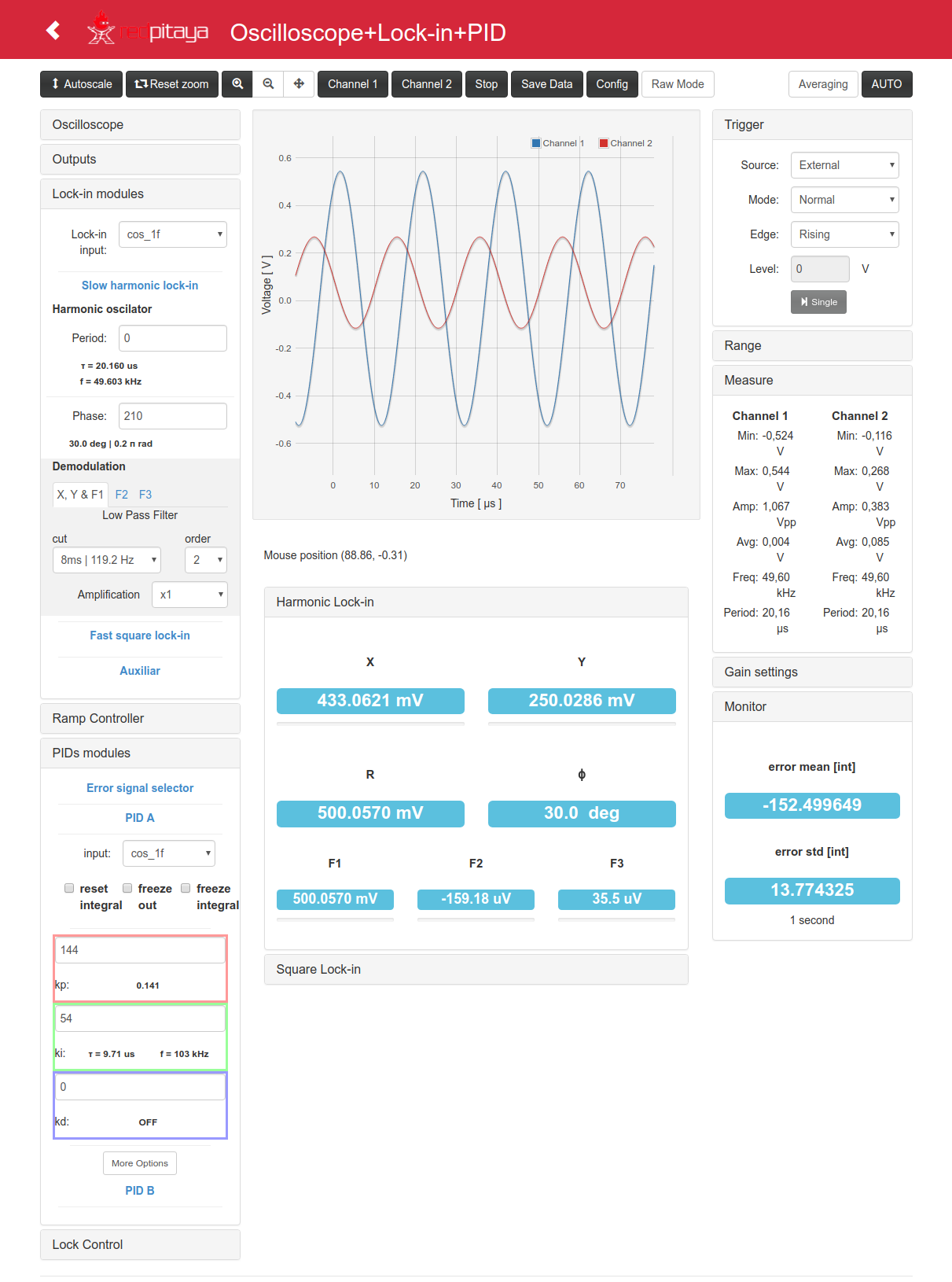

Figure 6: GUI of Web Version for Lock-In Amplifier hosted on RP Board.

These were the Functions that were replicated with the help of the GitHub repository (link to that is at the end of the report)

* Web control interface
* Python-based remote control (designed for Spyder under Linux)
* Complete Free Software source code.
* Oscilloscope application
* Lock-in amplifier (only with internal oscillator)
* Modulation generator
  + Harmonic functions (from 3 Hz to 50 kHz)
    - Two 1f functions in quadrature (sine and cosine)
    - One 1f function with phase control
    - One 2f function with phase control
    - One 3f function with phase control
  + Square functions (from 30 mHz to 31 MHz)
    - Two 1f functions in quadrature
    - One 1f function with phase control
* Scan control
  + Ramp scan generator
* Two configurable PID filters
  + Proportional, Integral and Derivative controllers
  + Set-point control
  + Several order of magnitudes
* Lock controller
  + System for making closed-loop stabilization schemes
  + Graphic tool for lock start-point selection
  + Auto-lock / relock system

**Here are the full instructions on how to run the program and host it on red pitaya**:

# Red Pitaya Lock-in+PID Application

## Lock-in and PID application for RedPitaya environment

This application was built for the [Red Pitaya STEMlab 125-14] board (RP).

The board is closed-hardware and open software.

If you have a RP board, you can install the **Lock-in+PID** application

by copying the `lock_in+pid` folder (that comes with this tar/zip file) to the

`/opt/redpitaya/www/apps` folder (inside the RP).

## Software requirements

build the Red Pitaya components:

1. Various development packages:

| ```bash  sudo apt-get install make u-boot-tools curl xz-utils nano  ``` |
| --- |

2. Xilinx [Vivado 2015.2]

(http://www.xilinx.com/support/download/index.html/content/xilinx/en/downloadNav/vivado-design-tools/2015-2.html) FPGA development tools. The SDK (bare metal toolchain) must also be installed, be careful during the installation process to select it. Preferably use the default install location.

3. Linaro [ARM toolchain]

(https://releases.linaro.org/14.11/components/toolchain/binaries/arm-linux-gnueabihf/) for cross-compiling Linux applications, recommend to install it to `/opt/linaro/` since build process instructions rely on it.



4. Missing `gmake` path

Vivado requires a `gmake` executable which does not exist on Ubuntu. It is necessary to create a symbolic link to the regular `make` executable.

| ```bash  sudo ln -s /usr/bin/make /usr/bin/gmake  ``` |
| --- |

5. On Ubuntu Linux this is also needed

| ```bash  sudo apt-get install make u-boot-tools curl xz-utils  sudo apt-get install libx32gcc-4.8-dev  sudo apt-get install libc6-dev-i386  ``` |
| --- |

The building was tested on Ubuntu 16.04 Linux x86_64

## Building

Run on terminal:

| ```  $ source settings.sh  $ make  ``` |
| --- |

Or form App folder `lock_in+pid`:

| ```  $ source ../settings.sh  ``` |
| --- |

and then...

For web controller C code compiling:

| ```  $ make app  ``` |
| --- |

For FPGA implementation:

| ```  $ make fpga  ``` |
| --- |

For zip packaging

| ```  $ mkdir -p ../archive  $ make zip  ``` |
| --- |

For tar.gz packaging

| ```  $ mkdir -p ../archive  $ make tar  ``` |
| --- |

For cleaning:

| ```  $ make clean # clean all  $ make clean_app # clean only C objects  $ make clean_fpga # clean only FPGA implementation temp files and .bin  ``` |
| --- |

# Upload App to Red Pitaya device

Unzip the App folder. Execute from the terminal:

| ```  $ ./upload_app.sh rp-XXXXXX.local  ``` |
| --- |

Replace `rp-XXXXXX.local` by your RP localname or IP address

upload the lock_in+pid folder the

RedPiaya folder: `/opt/redpitaya/www/apps`

All the work can be found here [8]

**4. MICRO-HEATER**

In order toachieve the High Temperature of order 1000k with a low power consumption and without losing the heat due to the large surface, a micro-scale heater made up of tungsten was constructed in a group of four.

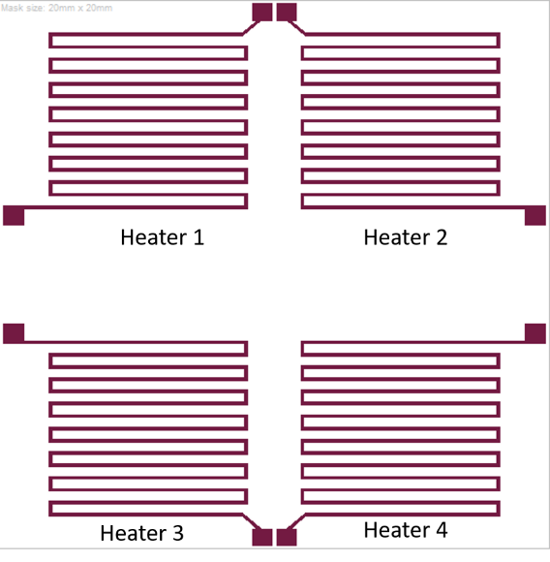

Figure 7: Design of micro heater

**4.1 Circuit diagram**

The circuit is designed to provide a constant current regardless of changes in resistance due to the heat increment in the heater. Here is the circuit diagram for the same. The circuit consists of a D-Flip-Flop, Timer IC and two Operational Amplifiers (Op-Amp).

A D (delay) flip flop acts as an electronic memory component since the output remains constant unless deliberately changed by altering the state of the D input followed by a rising clock signal.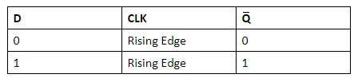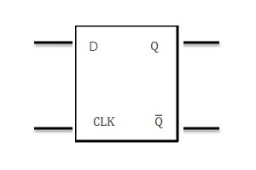

Figure 8: D Flip-Flop and Truth Table

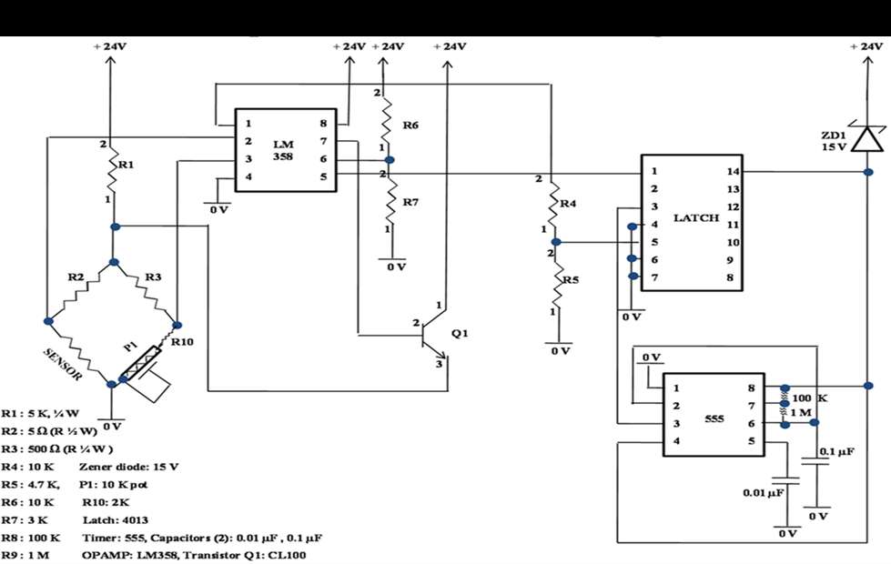

Figure 9: Circuit diagram for heater Controller.

**4.2 Construction of Heater**

In order to create an operational amplifier, the LM358 IC is used. There are two operational amplifiers in the system. LATCH CD4013B IC is utilized since it contains two D flip-flops, but only one is required, and it is controlled by another timer, in this case, the 555 IC. As a switch, an NPN transistor is used. A potentiometer and a fixed voltage divider can be used to control a relatively tiny current. The circuit is built using the preceding schematic. An external PID is also used to maintain a steady temperature.

The PID controls the Controller Circuit and keeps it turned on until it reaches the given

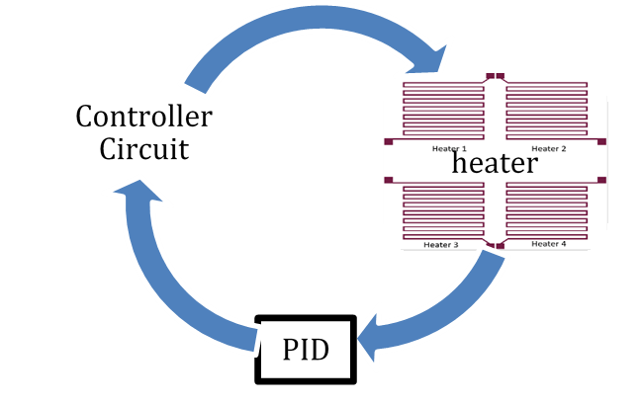

Figure 10: Schematic of Controller Circuit and Heater

temperature and then follows the feedback from the heater to regulate the temperature at a constant. All the construction was done, and the circuit was tested with a four-ohm heater.

**5. THERMAL EXPANSION USING LVDT**

To measure the thermal expansion with high precision, we measure elongation in one direction (length only) of a given material with the help of an LVDT.

**5.1 LVDT**

Linear Variable Differential Transformer is the abbreviation for this device. A hollow cylinder of insulating material serves as its main component. This insulating cylinder has one main winding P and two secondary windings S1 and S2 looped around its circumference. In the middle of the insulating cylinder lies the main winding P, and on either side of it are two secondary windings, S1 and S2, coiled in complete opposition to one another. In other words, S1 and S2 are moving in opposite directions. A magnetic or armature core is put within the insulating hollow cylinder and can move freely in both directions. Attaching the soft iron core to the object under study allows for the measurement of displacement. Nickel is commonly used in softcore because of its great sensitivity. [9]

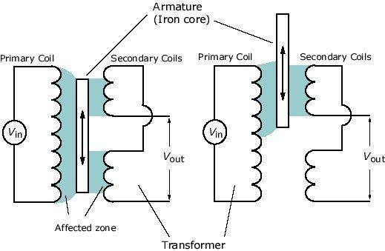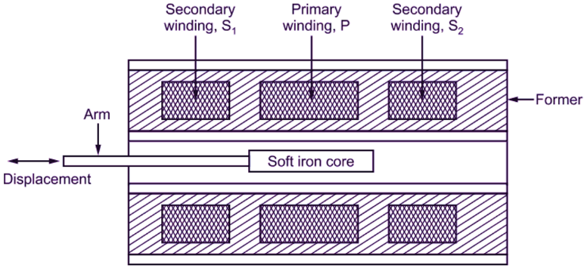

Figure 11: LVDT Inside View and Position Change View

**5.2 Why use LVDT?**

When the primary winding is supplied with an alternating current, a magnetic flux is generated that travels through both S1 and S2. Primary winding flux is proportional to secondary winding conductor count.

From Faraday’s law of electromagnetic induction, an EMF is produced in the secondary winding.

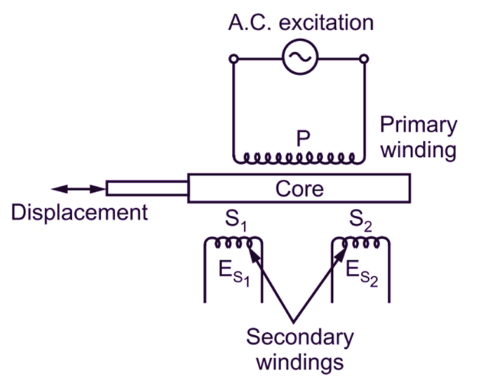

Figure 12: Circuit diagram of LVDT primary winding and Secondary winding

Es1 is the voltage produced by the S1 coil, while Es2 is the voltage produced by the S2 coil. Since S1 and S2 are wrapped in the opposite directions, they must be connected in series to create a single voltage, with a phase difference of 180 degrees. Because of this, the transducer's output will be the difference between the two voltages produced by the device.

E = Es1 – Es2

For displacements up to 5 mm, the transducers' voltage output is linear. There are no discrete steps in the voltage output, and the resolution is more a function of the testing apparatus than the transducer itself. Since the output voltage is large and easily measurable, no further intermediary amplifiers are required. The transducer can withstand significant vibration and stress because of its high sensitivity of 40V/mm. Most importantly, the measuring system is insensitive to changes in temperature and suffers no loss due to friction. This attribute is necessary because of its proximity to a high-temperature furnace. [9]

**5.3 Circuit Diagram for LVDT**

An AC power source of 12V at 50-60 Hz is used to power the LVDT, and an Arduino is used to read its analogue outputs. The Arduino's A0 analog read pin is wired to the secondary coil differential voltage. The range of numbers that can be read by an Arduino UNO is 0 to 1023. hence 1024 is subtracted from the maximum voltage input to the analogue pin. Additionally, a safe voltage range for the board's derivation is between 5V and 9V.

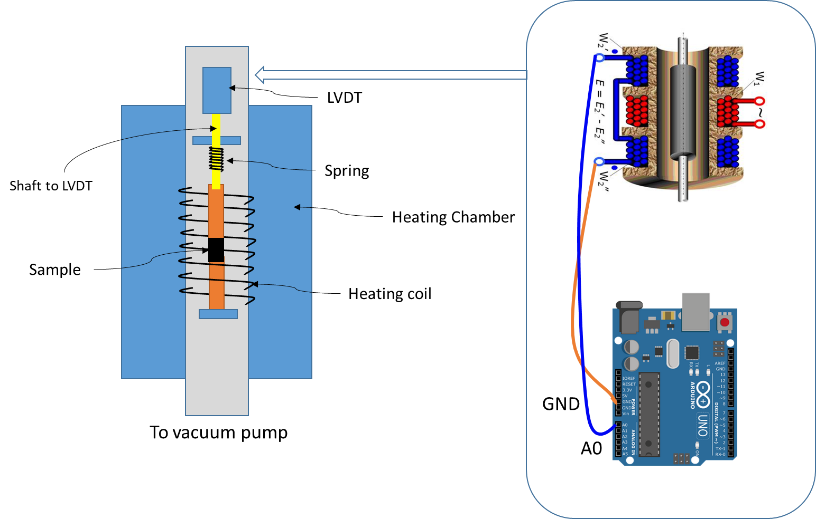

Figure 13: Arduino Interface With LVDT

**5.4 LVDT With Arduino and calibration**

When the core shifts to the left or right to the zero position. There will be an increase or decrease in the output difference. In this case, the LVDT's output voltage is a linear function of core displacement up to a certain point (5 mm from the LVDT's null position limit). This graph displays the variation in output voltage versus displacement.

For modest displacements, the curve is linear, but beyond around 5 mm, it begins to break from a straight line.[9]

Figure 14: Displacement vs Output Voltage 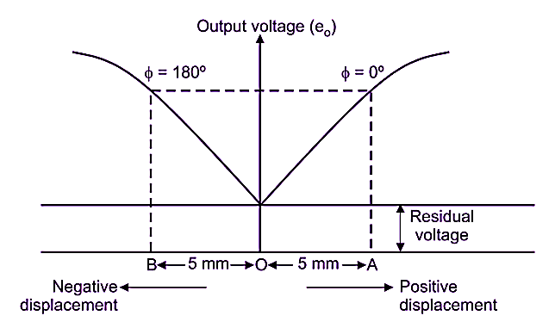

**5.4.1 Code for Arduino**

This code is just to read the analog output from the secondary coil of the LVDT,

and print it on the Serial monitor at a 115200 baud rate.

| // the setup routine runs once when you press reset:  void setup() {    // initialize serial communication at 115200 bits per second:  Serial.begin(115200);  Serial.print("start");  delay(1000);  }  // the loop routine runs over and over again forever:  void loop() {  // read the input on analog pin 0:  int sensorValue = analogRead(A2);  // Convert the analog reading (which goes from 0 - 1023) to a voltage (0 - 5V):  //float voltage = sensorValue * (5.0 / 1023.0);  // print out the value you read:  Serial.println(sensorValue);  delay(50);  } |
| --- |

**6. RESULTS**

**6.1 Noise reduction and amplification**

The mobile web version with Red Pitaya gave the output sine wave of 1v Amplitude and 8KHz frequency.

Figure 15: Signal noise Detection on Lock-in GUI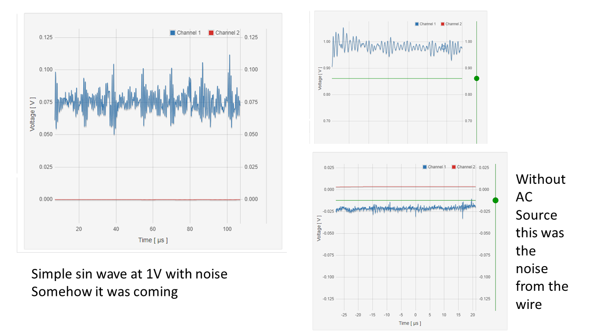

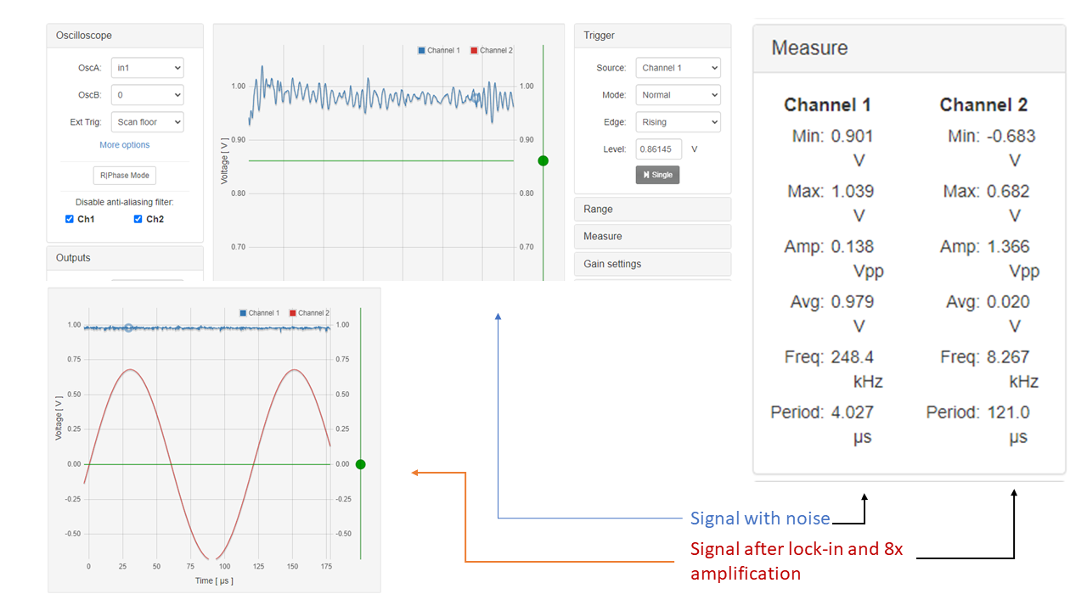

Figure 16: Signal after Lock-in and eight times Amplification

**6.2 High temperature with the microheater**

A constant current of 0.2 mA was applied to a heater of resistance 4 ohms and the voltage drop across the resistor was found to be 18 V. Therefore, the power dissipated is calculated to be 0.36 mW. Although, the heating was observed the exact temperature of the heater is yet to be measured.

**6.3 LVDT graph variation**

* Reversal of current flow in the secondary coil was achieved by gradually shifting a soft iron core from a -5mm to a +5mm distance and the voltage to time graph was plotted.
* Large changes in output voltage are visible even in a stable condition of the core, as seen by the variation voltage.
* The fluctuation remains the same after using a voltage divider to drop the output voltage.

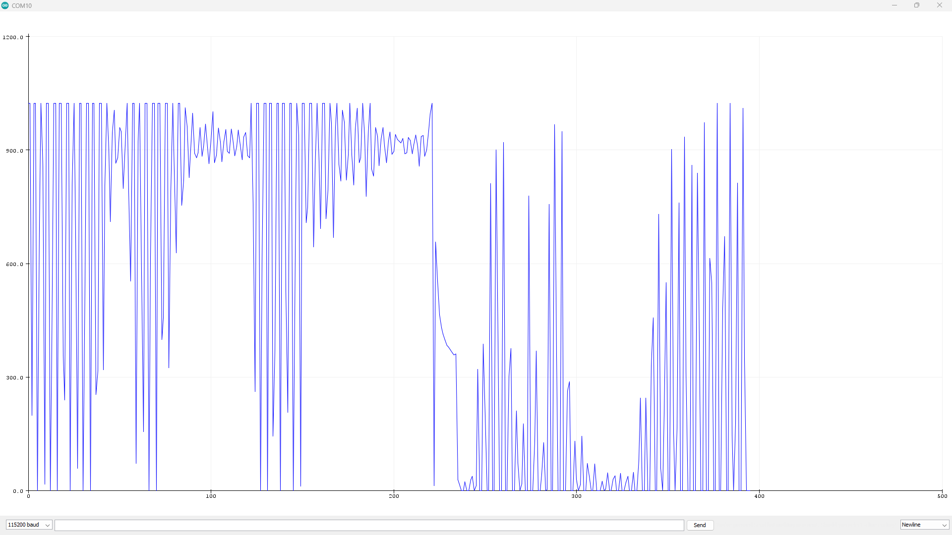

Figure 17: voltage vs time graph for LVDT

**7. CONCLUSIONS**

The Red Pitaya board was able to glean a 1V signal at 8KHz frequency from an extremely chaotic one. The resistance heater wire of 4 ohms proved successful in maintaining a steady current of 0.002Amp. Outputs from the devices to confirm the reliability of the constructs. Further integration of these components in experimental set-up can test their usability and efficiency.

When using an LVDT to monitor displacement, the device's output voltage was erratic even when the core was at rest, indicating a problem with the AC input Source. Further investigation and calibration are needed for the device.

**8. APPENDIX**

More on lock-in amplifiers can be found here at Git Hub

[**Release v0.3.7 · marceluda/rp_lock-in_pid_h (github.com)**](https://github.com/marceluda/rp_lock-in_pid_h/releases/tag/v0.3.7)

**9. REFERENCES**

[1] Lock-in Amplifiers. (2019, December 20). Zurich Instruments.

[2] Richard Wolfson; The lock‐in amplifier: A student experiment. *American Journal of Physics* 1 June 1991; 59 (6): 569–572. <https://doi.org/10.1119/1.16824>

[3] [Microsoft Word - Lock-in amplifier.doc (princeton.edu)](https://www.princeton.edu/~romalis/PHYS312/Lock-in%20amplifier.pdf)

[4] What is an FPGA? Field Programmable Gate Array. (n.d.). Xilinx

[5] Oscilloscope & Signal generator - Red Pitaya. (2021, June 14). Red Pitaya.

[6] Principles of Lock-in Detection. (2019, December 20). Zurich Instruments.

[7] luda, M. (n.d.). Lock-in+PID. Lock-in+PID.

[8] M. (2022, March 11). GitHub - marceluda/rp_lock-in_pid: Lock-in and PID application for RedPitaya environment. GitHub.

[9] Editor, I. (2023, January 10). What is LVDT ? | Types & Applications. THE INSTRUMENT GURU. <https://theinstrumentguru.com/what-is-lvdt-types-applications/>

Figure source

Figure 1: [The Red Pitaya Board (marceluda.github.io)](https://marceluda.github.io/rp_lock-in_pid/TheApp/RedPitaya_board/)

Figure 2: [The Red Pitaya Board (marceluda.github.io)](https://marceluda.github.io/rp_lock-in_pid/TheApp/RedPitaya_board/)

Figure 3: https://www.zhinst.com/sites/default/files/images/2022-12/lockin_01_signal_buried_final_2022.svg

Figure 14 : https://electricalworkbook.com/wp-content/uploads/2021/07/What-is-LVDT.png

Figure 11: https://theinstrumentguru.com/wp-content/uploads/2023/01/LVDT.jpg